**Task 1 Basic Classes**

**UserDetails Testing Screenshots:**

**UserDetails – All-Arg Constructor**

**UserDetails – 2-Arg Constructor**

**UserDetails – 1-Arg Constructor**

**UserDetails – No-Arg Constructor**

**GameSettings Testing Screenshots:**

**Debugging Screenshots:**

**GameSettings - All-Arg Constructor**

**GameSettings - No-Arg Constructor**

**Task 2 – Aggregation Class**

**GameDetails Testing Screenshots:**

**Task 3 – Inheritance Class**

**BorderEntity Testing Screenshots:**

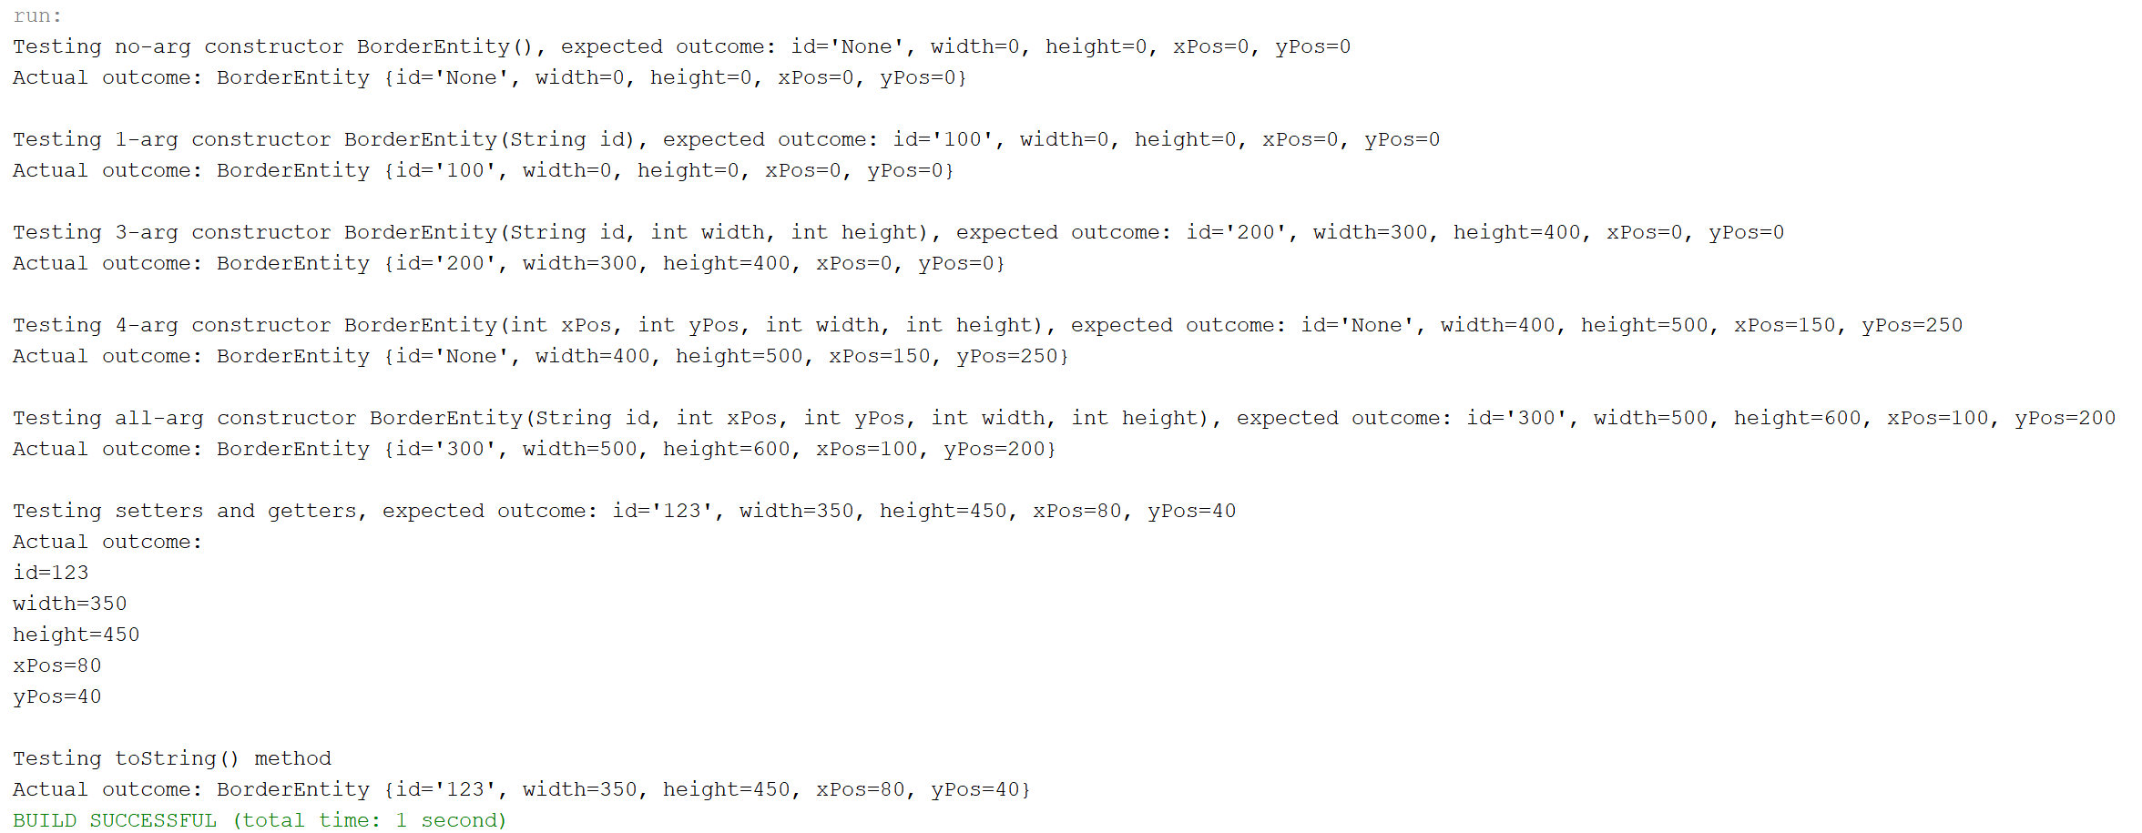

**Task 4 –Arrays**

**EntityListArray Testing Screenshots:**

**Task 5 –Files**

**GameDetailsDB Testing Screenshots:**

